**ISL**

**Section # 3**

**Day 1 *lesson plan***

**Introduction:**

**Course**: EDTD 6364

**Date Submitted**: Blank

**Date Approved**: Blank

**Date Taught**: Blank

**Grade Level**: First Grade Special Education Math

**Length of Lesson**: 50/minutes

**Standard:**

**CCGPS.1.NBT.2 Understand that the two digits of a two digit number represents amounts of tens and ones. Understand the following as special cases:**

a.**10 can be thought of as a bundle of ten ones – called a “ten.”**

This standard asks students to unitize a group of ten ones as a whole unit: a ten. This is the foundation of the place value system. So, rather than seeing a group of ten cubes as ten individual cubes, the student is now asked to see those ten cubes as a bundle – one bundle of ten.

b. The **numbers 10, 20, 30, 40, 50, 60, 70, 80, 90 refer to one, two, three, four, five, six, seven, eight, or nine tens (and 0 ones).**

This standard builds on the work of CCGPS.1.NBT.2b. Students should explore the idea that decade numbers (e.g., 10, 20, 30, 40…) are groups of tens with no left over ones. Students can represent this with cubes or place value (base 10) rods. (Most first grade students view the ten stick (numeration rod) as ONE. It is recommended to make a ten with unfix cubes or other materials that students can group. Provide students with opportunities to count books, cubes, pennies, etc. Counting 30 or more objects supports grouping to keep track of the number of objects.)

**Objectives:**

1. Students will be able to unite a group of ten ones as a whole unit (“a ten”). They will be able to count groups as though they were individual objects.
2. Students will be able to group objects into ten and ones, describe how many groups and left- overs there are, and use that information to explain how many objects are in total.
3. Students will be able demonstrate with a variety of manipulative materials that are proportional (e.g., cubes, links, beans, beads) and ten frames that a numeral can stand for many different amounts, depending on its position or place in a number.

**Essential Questions:**

How can numbers 10 and higher be shown, counted, read and written?

How can we use groups of ten units to express higher numbers?

**Materials:**

* “Sir Cumference and All the King’s Tens”
* Worksheets
* Smiley face stickers
* Pencils
* Illustrations
* Puzzles

**Activator:**

Reading of the story “Sir Cumference and All the King’s Tens: A Math Adventure” by Cindy Neuschwander. This books helps introduce the students to the concept of counting by tens. The illustrations in the book help students visualize the groups of tens as they are being described. In the story Sir Cumference and Lady Di are organizing a dinner party at the castle. The need to have enough food and seating for the guests and they count by tens to make it more organized.

(10 MINUTES ACTIVITY)

**Lesson:**

* The teacher will divide the classroom in pairs

***“Let’s practice counting groups of tens”***

* *The teacher will state the purpose of the lesson.*

***“Today we will count groups of ten up to one hundred and tell how many.”***

* The students will host a dinner party just like Sir Cumference and Lady Di did in the story.
* The teacher will provide them with a sheet of paper with the “tables” in which the guests to the party will be seating. And smiley face stickers that will represent the guests to the party.
* The teacher will demonstrate how to place 10 individual stickers in one table.

***“How many guests do we have here?”* 10**

***“How many groups of ten did we make?”* one**

* Each pair of students will have a different number of guests. They will work together to have them seated in the tables. Each table can only hold ten guests.
* The students will then complete the written sentences beside each table to help them count the total number of guests.
* The teacher will walk amongst the student pairs monitoring their progress and reminding the essential questions.

***“Remember we are counting groups of tens”***

***“How can numbers 10 and higher be shown, counted, read and written?”***

***“How can we use groups of ten units to express higher numbers?”***

(20 MINUTES ACTIVITY)

**Name_________________________ Date______________**

**         **

**Sit each guest at a table. Only 10 guests on each table.**

____ ten = ____ guests

**         **

____ ten = ____ guests ____tens = ______ guests

**         **

____tens = ______ guests

____tens = ______ guests

**         **

Created by Maria Bastian.

____tens = ______ guests

Created by Maria Bastian

* The teacher will make use of visual aids to illustrate how you can use groups of tens to name and count numbers. On the board the teacher will show the students the followings Illustrations:

You can make use of **10** cubes to make **1** ten

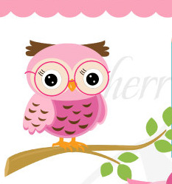

**1 Ten**

* The teacher will ask the following questions:

“Do you see a group of ten in this picture? Yes

“Why is this called 1 Ten?” There are 10 cubes in one group

Here are 5 tens

1 ten, 2 tens, 3 tens, 4 tens, 5 tens



* The teacher will ask the students

“How many groups of ten we see in this picture?” Five

“How many tens are in this picture?” Five

Skip count by tens to find the number of cubes

10, 20 30, 40 50



* The teacher will explain to the students:

**“You know that 1 ten has 10 cubes. How can you find the number of cubes without counting each cube?”** Skip count by 10’s

**“Skip count by 10’s to find the number of cubes in all.”** Have the children point to each ten as they count.

**“What patterns do you notice when you count by 10’s?** The first digit increases by 1 every time you add 10 more

How many cubes are there in all?



**There are 50 cubes in all**

**5 Tens is 50**

(10 MINUTES ACTIVITY)

Lesson excerpt from enVisionMATH Common Core. Illustrations by Cherrie Graphics.

* The teacher will allow the students to keep working in pairs. Each pair of students will be given two puzzles. Each piece of the puzzle expresses a number in a different way.

Created by Maria Bastian

**30**

**3 tens**

Thirty

Created by Maria Bastian

* As the students complete their puzzles have them compare and experiment with the different ways to express a number.

The teacher will remind the students the essential questions

***“How can numbers 10 and higher be shown, counted, read and written?”***

***“How can we use groups of ten units to express higher numbers?”***

* The students will discuss with each other the relationship between the number of tens and its decade number.

(20 MINUTES ACTIVITY)

**Differentiated Instruction:**

* The special needs children in our classroom have different needs that have to be addressed. For those children with orthopedic challenges that make it hard for them to hold the pencil or color we will provide them with the tables already filled with the stickers and have them circle the right number from a list of choices. For the puzzle activity they will be paired with a peer that will assist them in putting the pieces together.
* For our ELL students we will reinforce the language skill in the presentation of this unit by emphasizing for them the vocabulary. To verify understanding we will use the strategy **report back** and have the student repeat or complete key sentences. We will reinforce the idea that words like ***thirty*** or ***twenty*** mean groups of ten and at the same time allowing them to see the meaning of the words by the use of manipulative resources.
* For our student below level we will use cooperative learning to have a peer work with them on the lessons activities so they can model their work by observing the peer work.

**Vocabulary:**

**Tens**

The digit in the tens place shows how many groups of t10 are in a number

**Ones**

The digit in the ones place shows how many ones are left over after all the groups of 10 have been made

**Digit**

The symbols that make up a number.

**Closing:**

* The purpose of this lesson was for you to learn that if all the objects are in groups of ten, you can count by tens to find how many objects there are.
* In the number 100 there are ten groups of tens.
* Counting by tens can help us find out how many objects are in all.
* The teacher will as the students:

**“How can we know how many objects there are in 6 tens?”**

(5 MINUTES ACTIVITY)

**Quick Check:**

* The teacher will distribute an exercise sheet 5 minutes before the end of the class to assess if the students are comprehending the material.

Name________________________ Date______________

1. What number completes the pattern?

30, 40, 50, 60, _____, 80, 90, 100

* 1. 70
  2. 20
  3. 17
  4. 10

1. Which group of ten’s show that 5 tens is 50?
2. Draw a picture to illustrate your answer. Write the number.

Jan collects stamps and puts them in a book. She puts 10 stamps on each page of the book.

How many pages will Jan need for 40 stamps?

_______ Pages

Formative Assessment from envision MATH.

# References

Clipart, M. O. (n.d.).

Meyers, C. (n.d.). *Pink Owl.* Cherrie Graphics, New York.

Murphy, S. J. (1998). *A Fair Bear Share.* New York: Harper Collins Publishers.

Neuschwander, C. (2009). *Sir Cumference and All the King's Tens: A Math Adventure.* London: Charlesbridge Publishing.

Scott Foresman, A. W. (2010). *Envision Math Common Core.* New Jersey: Pearson Education.

***Day2 lesson Plan***

**Introduction:**

**Course**: EDTD 6364

**Date Submitted**: Blank

**Date Approved**: Blank

**Date Taught**: Blank

**Grade Level**: First Grade Special Education Math

**Length of Lesson**: 50/minutes

**Standard:**

**CCGPS.1.NBT.2 Understand that the two digits of a two digit number represents amounts of tens and ones. Understand the following as special cases:**

1. **10 can be thought of as a bundle of ten ones – called a “ten.”**

This standard asks students to unitize a group of ten ones as a whole unit: a ten. This is the foundation of the place value system. So, rather than seeing a group of ten cubes as ten individual cubes, the student is now asked to see those ten cubes as a bundle – one bundle of ten.

b. The **numbers 10, 20, 30, 40, 50, 60, 70, 80, 90 refer to one, two, three, four, five, six, seven, eight, or nine tens (and 0 ones).**

This standard builds on the work of CCGPS.1.NBT.2b. Students should explore the idea that decade numbers (e.g., 10, 20, 30, 40…) are groups of tens with no left over ones. Students can represent this with cubes or place value (base 10) rods. (Most first grade students view the ten stick (numeration rod) as ONE. It is recommended to make a ten with unfix cubes or other materials that students can group. Provide students with opportunities to count books, cubes, pennies, etc. Counting 30 or more objects supports grouping to keep track of the number of objects.)

**Objectives:**

1. Students will be able to unite a group of ten ones as a whole unit (“a ten”). They will be able to count groups as though they were individual objects.
2. Students will be able to group objects into ten and ones, describe how many groups and left- overs there are, and use that information to explain how many objects are in total.
3. Students will be able demonstrate with a variety of manipulative materials that are proportional (e.g., cubes, links, beans, beads) and ten frames that a numeral can stand for many different amounts, depending on its position or place in a number.

**Essential Questions:**

1. How can we make a ten unit?
2. How can we divide numbers in units of tens and ones?

**Materials:**

* A Fair Bear Share
* Worksheets
* Pencils
* Illustrations of the pie ingredients

**Activator:**

Reading of the book “A Fair Bear Share” by Stuart J. Murphy. This books introduces to children the concept of grouping. The plot of the store turns around bear cups that are counting and gathering the ingredients to make a pie.

(10 MINUTES ACTIVITY)

**Lesson:**

To activate the prior knowledge of the students we will practice counting groups of ten, as the cubs in the activator story did to determine the right amount of ingredients for the pie. We can make an imaginary pie in the classroom and count the groups of ten of each ingredient.

* We will direct the instruction by asking questions and stating clear instructions.

***“We will be counting in groups of tens and ones”***

***“Let’s practice counting groups of tens”***

**“*How many apples do we have for our pie?”***

***“How many groups of tens can we count for this ingredient?”***

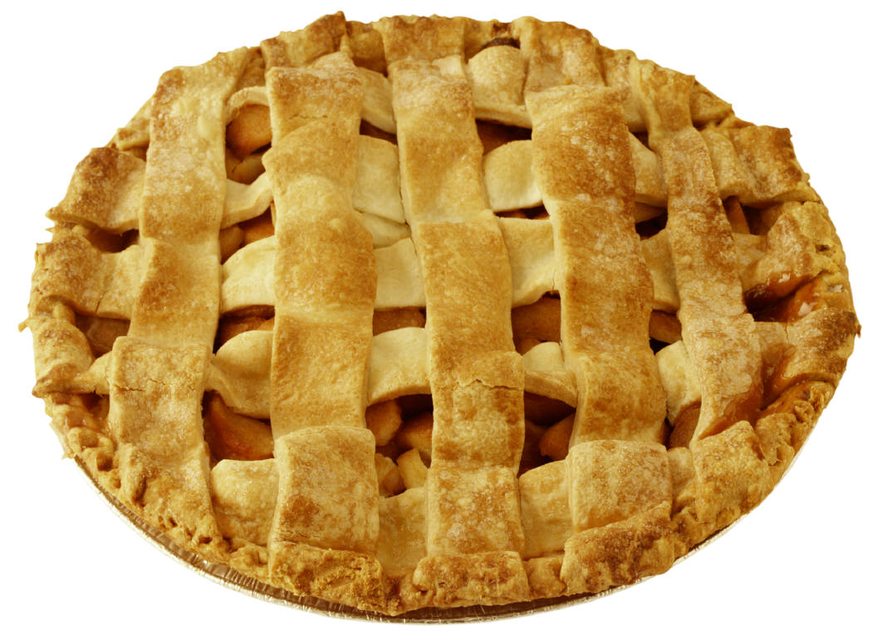



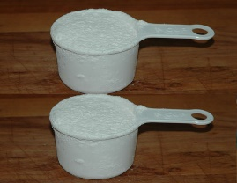





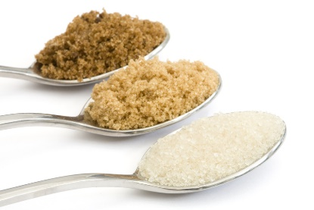

***“Do we have more than ten units of this ingredient?”***

***Repeat the essential questions:***

How can we make a ten unit?

How can we divide numbers in units of tens and ones?

(20 MINUTES ACTIVITY)

* The teacher will pass out a sheet with apples the students will color 10 apples in red and the rest in green. They will write the whole number of apples in the paper, identify how many groups of tens and ones are in it.

(15 MINUTES ACTIVITY)

Name________________________ Date____________________

**Color 10 apples red. Color the rest green**

**    **

**    **

    

15

**There are________ apples in this page.**

1

**There is _____ group of ten.**

5

**There are______ones.**

**Created by Maria Bastian/ Images property of Microsoft clipart.**

* The teacher will help the students fill in the numbers and direct the students learning with questions.

**“How many groups of ten red apples did you count?”**

**“How many green apples?”**

**Repeat the essential questions**

How can we make a ten unit?

How can we divide numbers in units of tens and ones?

This will help guide the students learning as they answers the questions.

**Differentiated Instruction:**

* The special needs children in our classroom have different needs that have to be addressed. For those children with orthopedic challenges that make it hard for them to hold the pencil or color we will use the computer or a tablet to allow them to just click on the right answers or click on the color on the painting program to complete a task similar to their peers.
* For our ELL students we will reinforce the language skill in the presentation of this unit by emphasizing for them the vocabulary. To verify understanding we will use the strategy **report back** and have the student repeat or complete key sentences. We will reinforce the idea that words like ***thirty*** or ***twenty*** mean groups of ten and at the same time allowing them to see the meaning of the words by the use of manipulative resources.
* For our student below level we will use cooperative learning to have a peer work with them on the lessons activities so they can model their work by observing the peer work.

**Vocabulary:**

**Tens**

The digit in the tens place shows how many groups of t10 are in a number.

**Ones**

The digit in the ones place shows how many ones are left over after all the groups of 10 have been made.

**Digit**

The symbols that make up a number.

**Closing:**

* Ask the students :

“What have we learned today?”

“Can anyone demonstrate how can we make a ten unit with these materials?”

(Present the students with some manipulative materials)

“If we have 25 units how can we divide it in tens and ones units?”

(5 MINUTES ACTIVITY)

**Ticket out the door:**

* The teacher will give each student an index card and have them answer the question written on the board.

**“How can we divide the number 25 in units of tens and ones?”**

# References

Clipart, M. O. (n.d.).

Meyers, C. (n.d.). *Pink Owl.* Cherrie Graphics, New York.

Murphy, S. J. (1998). *A Fair Bear Share.* New York: Harper Collins Publishers.

Neuschwander, C. (2009). *Sir Cumference and All the King's Tens: A Math Adventure.* London: Charlesbridge Publishing.

Scott Foresman, A. W. (2010). *Envision Math Common Core.* New Jersey: Pearson Education.

***Day 3 lesson Plan***

**Introduction:**

**Course**: EDTD 6364

**Date Submitted**: Blank

**Date Approved**: Blank

**Date Taught**: Blank

**Grade Level**: First Grade Special Education Math

**Length of Lesson**: 50/minutes

**Standard:**

**CCGPS.1.NBT.2 Understand that the two digits of a two digit number represents amounts of tens and ones. Understand the following as special cases:**

**a.10 can be thought of as a bundle of ten ones – called a “ten.”**

This standard asks students to unitize a group of ten ones as a whole unit: a ten. This is the foundation of the place value system. So, rather than seeing a group of ten cubes as ten individual cubes, the student is now asked to see those ten cubes as a bundle – one bundle of ten.

b. The **numbers 10, 20, 30, 40, 50, 60, 70, 80, 90 refer to one, two, three, four, five, six, seven, eight, or nine tens (and 0 ones).**

This standard builds on the work of CCGPS.1.NBT.2b. Students should explore the idea that decade numbers (e.g., 10, 20, 30, 40…) are groups of tens with no left over ones. Students can represent this with cubes or place value (base 10) rods. (Most first grade students view the ten stick (numeration rod) as ONE. It is recommended to make a ten with unfix cubes or other materials that students can group. Provide students with opportunities to count books, cubes, pennies, etc. Counting 30 or more objects supports grouping to keep track of the number of objects.)

**Objectives:**

1. Students will be able to unite a group of ten ones as a whole unit (“a ten”). They will be able to count groups as though they were individual objects.

2. Students will be able to group objects into ten and ones, describe how many groups and left- overs there are, and use that information to explain how many objects are in total.

1. Students will be able demonstrate with a variety of manipulative materials that are proportional (e.g., cubes, links, beans, beads) and ten frames that a numeral can stand for many different amounts, depending on its position or place in a number.

**Essential Questions:**

1. How can we divide numbers in units of tens and ones?

2. How can we use 10’s and 1’s to write a 2 digit number that can describe how many objects are in a group?

**Materials:**

* Mr. Base Ten Invents Mathematics
* Worksheets
* Pencils
* Work Mats
* Connecting cubes
* Dry erase markers

**Activator:**

Reading of the book “Mr. Base Ten Invents Mathematics” by Bethanie H. Tucker. This book describes how Mr. Base Ten invented several mathematical applications like the ones column and the tens column helping students visualize place value amongst other concepts.

(10 MINUTES ACTIVITY)

**Lesson:**

* The teacher will explain the purpose of the lesson.

**“Today you will use objects to show the tens and ones in a two digit number and then write the number.”**

* The teacher will present the essential questions to the students.

**“How can we divide numbers in units of tens and ones?”**

**“How can we use 10’s and 1’s to write a 2 digit number that can describe how many objects are in a group?”**

* The teacher will distribute a work mat and connecting cubes to the student
* Like Mr. Base ten the students will use column to place digits in the ones column and the tens column

(10 MINUTES ACTIVITY)

Name___________________ Date______________

Write the two digit number on the columns in two different ways.

|  |  |
| --- | --- |
| Tens | Ones |
| 3 | 4 |
|  |  |

**Example**: Write the number 34

**Ones**

**Tens**



**Write the number 21**

**Tens**

**Ones**

**Write the number 14**



Created by Maria Bastian

* The teacher will direct the attention of the students to the illustrations on the board

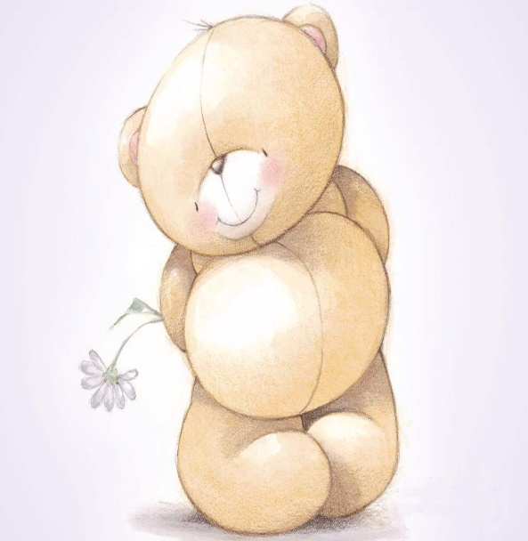

**45**

45 stands for 4 tens and 5 ones

* The teacher will ask the class:

“How are these numbers like 4 tens and 5 ones? 4 tens is 40 and 5 ones is 5

**45**

“So … we can say that 45 is 4 tens and 5 ones.”

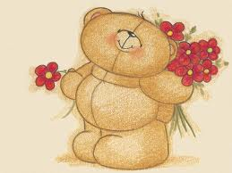 **The 4 in 45 is the tens digit**

45 has 2 **digits**

**The 5 in 45 is the ones digit**

* The teacher will define the new term for the students

“A digit is any of the numerals in either place in a number.”

“What are the digits in 45?” 4 and 5

“Which digit stands for 40?” 4

You can use a work mat to show the tens and ones

|  |  |
| --- | --- |
| **Tens text here** | **Ones** |
| 4 tens | 5 ones |

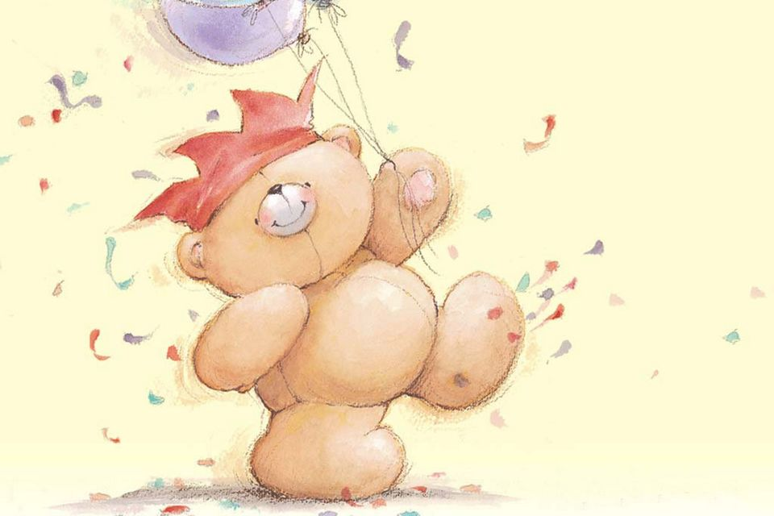

* When you use connecting cubes to show a number, you put the tens in the tens place on the place value mat. The left over cubes are called ones.
* The teacher will show the class a ten bar

“Where would you put this ten?” The tens place

* The teacher shows the students one cube

“Where would you put this cube? The ones place

“How many tens are there in 45?” 4

“How many ones are there in 45?” 5

|  |  |
| --- | --- |
| **Tens** | **Ones** |
| **4** | **5** |

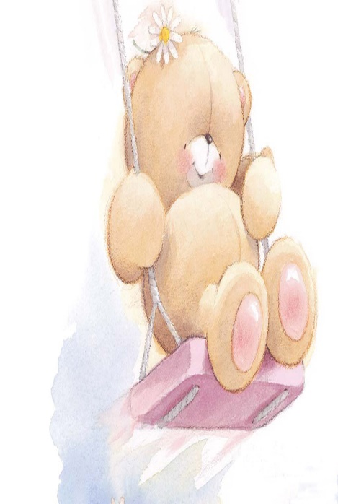

The tens digit goes on the left. The ones digit goes on the right

* The teacher will explain to the children:
* “You don’t have to put cubes on a place value mat. You can also write the numbers on the mat. The four in the tens place means there are 4 tens.

“What does the 5 in the ones place mean?” There are 5 ones

4 tens and 5 ones make 45. You can put the 4 and the 5 together to make the number 45

* The teacher will instruct the children to construct the number 45 on their work mat.
* The teacher and the student will practice constructing at least two more numbers on the work mat while the teacher walks through the classroom and monitors that everyone has understood the concept.

(30 MINUTES ACTIVITY)

Lesson excerpt from enVisionMATH/ Illustrations by iwallfinder/ Tables created by Maria Bastian

**Differentiated Instruction:**

* The special needs children in our classroom have different needs that have to be addressed. For those children with orthopedic challenges that make it hard for them to hold the pencil or color we will use the computer or a tablet to allow them to just click on the right answers or click on the color on the painting program to complete a task similar to their peers.
* For our ELL students we will reinforce the language skill in the presentation of this unit by emphasizing for them the vocabulary. To verify understanding we will use the strategy **report back** and have the student repeat or complete key sentences. We will reinforce the idea that words like ***thirty*** or ***twenty*** mean groups of ten and at the same time allowing them to see the meaning of the words by the use of manipulative resources.
* For our student below level we will use cooperative learning to have a peer work with them on the lessons activities so they can model their work by observing the peer work.

**Vocabulary:**

**Tens**

The digit in the tens place shows how many groups of t10 are in a number.

**Ones**

The digit in the ones place shows how many ones are left over after all the groups of 10 have been made.

**Digit**

The symbols that make up a number.

**Closing:**

* Ask the students :

“What have we learned today?”

“Can anyone demonstrate how can we make a ten unit with these materials?”

(The students will use the connecting cubes they have used during class)

“If we have 25 units how can we divide it in tens and ones units?”

(5 MINUTES ACTIVITY)

**Formative Assessment:**

Ticket out the door. The teacher will provide the students with the following work sheet. The students will demonstrate mastery of the skills needed to group numbers in units of tens and ones. They will write in their own words what did they learn in class this day.

**Name______________________ Date_______________**

**Fill the blanks with the correct answer**

**1 ten is 10 16 = 1 ten + 6 ones**

|  |  |  |  |  |
| --- | --- | --- | --- | --- |
|  |  |  |  |  |
|  |  |  |  |  |

**2 tens is 20 25= 2 tens + 5 ones**

|  |  |  |  |  |
| --- | --- | --- | --- | --- |
|  |  |  |  |  |
|  |  |  |  |  |

3 tens is 30

|  |  |  |  |  |
| --- | --- | --- | --- | --- |
|  |  |  |  |  |
|  |  |  |  |  |

31 = 3 tens + 1 one

**What did you learn in class today?**

# References

(2010-2013).*Cartoon Bear.* IWallFinder.com.

Clipart, M. O. (n.d.).

Meyers, C. (n.d.). *Pink Owl.* Cherrie Graphics, New York.

Murphy, S. J. (1998). *A Fair Bear Share.* New York: Harper Collins Publishers.

Neuschwander, C. (2009). *Sir Cumference and All the King's Tens: A Math Adventure.* London: Charlesbridge Publishing.

Scott Foresman, A. W. (2010). *Envision Math Common Core.* New Jersey: Pearson Education.

Tucker, B. H. (2002). *Mr. Ten invents Mathematics.* Highlands: aha!Process.